**Importing Json Files into Hive**

**Hive:**

Apache Hive is an open-source data warehouse system for querying and analysing large datasets stored in Hadoop files. Hadoop is a framework for handling large datasets in a distributed computing environment.

**JSON File Format:**

**JSON** (JavaScript Object Notation) is a lightweight data-interchange **format**. It is easy for humans to read and write. It is easy for machines to parse and generate. It is based on a subset of the JavaScript Programming Language, Standard ECMA-262 3rd Edition - December 1999.

Let us consider the following data set stored as color.json

{"color": "red","value": "#f00"},

{"color": "green","value": "#0f0"},

{"color": "blue","value": "#00f"},

{"color": "cyan","value": "#0ff"},

{"color": "magenta","value": "#f0f"},

{"color": "yellow","value": "#ff0"},

{"color": "black","value": "#000"}

**Procedure**:

**Step 1:**

Move the data into HDFS using the following command.

**Command**:

Hadoop fs –put Desktop/color.json /user/JSON

**Step 2:**

Open Hive.

**Command:**

Hive

**Step 3:**

Create or use a database using the following command.

**Command**:

Use Mydb;

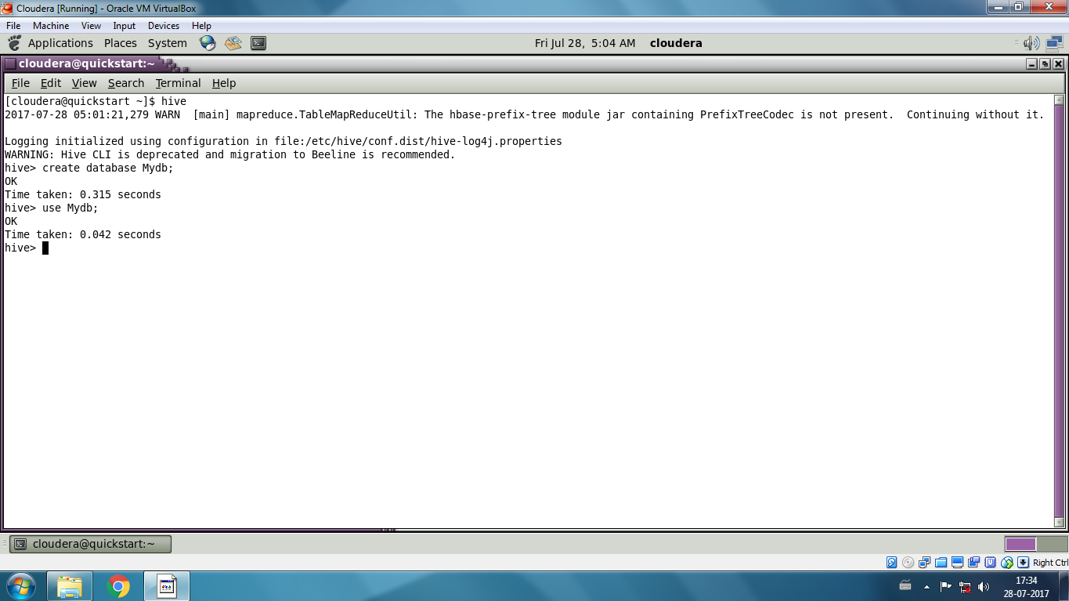

**Step 4:**

Create a table using the following command.

**Command:**

Create table Arun (data String);

**Step 5:**

Move Data into the table using the following command.

**Command:**

Load data inpath ‘/user/JSON/color.json’ overwrite into table Arun;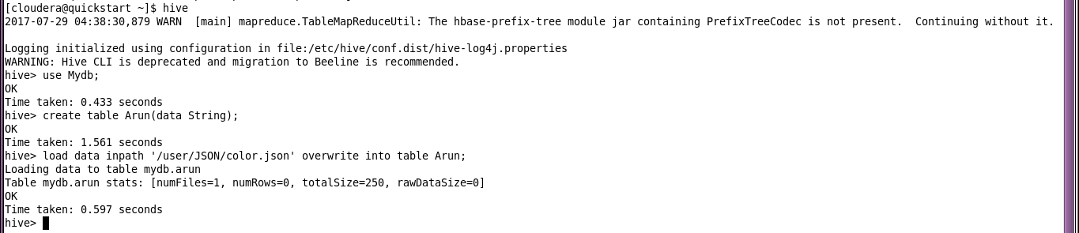

**Step 6:**

View the data in the table using the following commands.

Select * from Arun;

(or)

Select get_json_object (Arun.json,’$.color’) as Name from Arun;